**Problem**

Asset can work in different projects and it can work in many projects for the same month

For example

Project A 5 days

Project B 15 days

Project C 11 days

**Required**

When we calculate depreciation we need to calculate it for each project based on how many days every asset work on each project.

And when we post depreciation to GL we need to post it by cost center.

**Solution**

The solution is developed and will be on the next version, for now this is over view in case a client need this feature now and can’t wait:

For activate this feature for any client need it in the next version, there is new parameter add

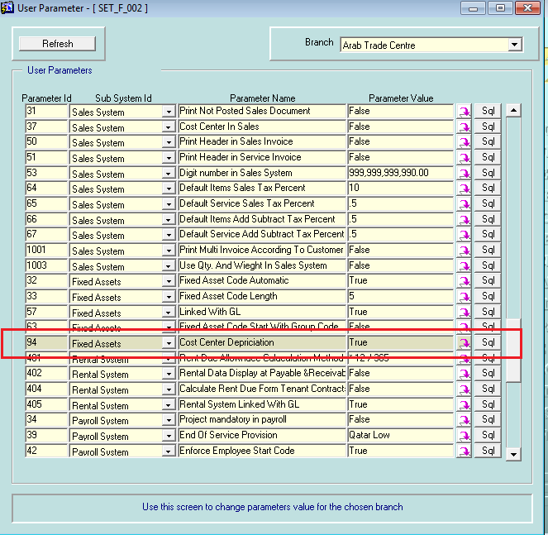

New screen added to enable u to transfer the assets between departments

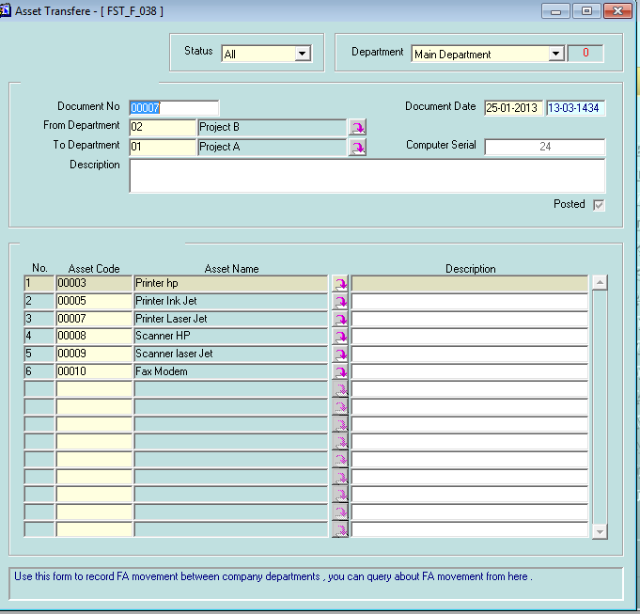

U can print the asset transfer document

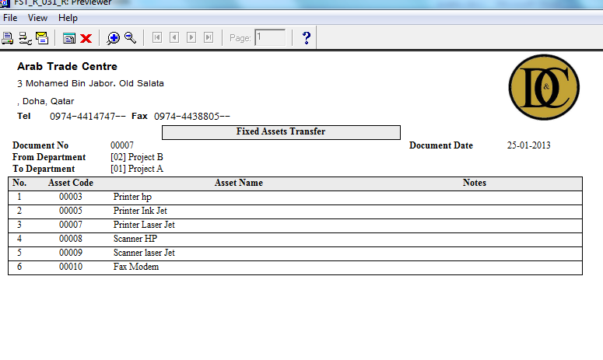

Which will make transaction in the asset transfer history

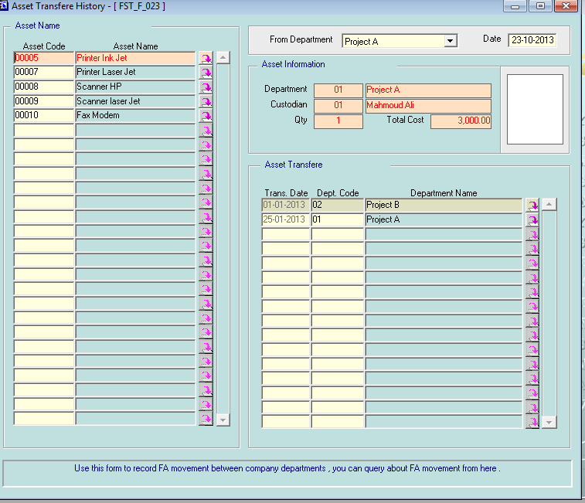

When u calculate depreciation it will calculate the deprecations for each department for every asset based on how many days every asset work in each department as shown

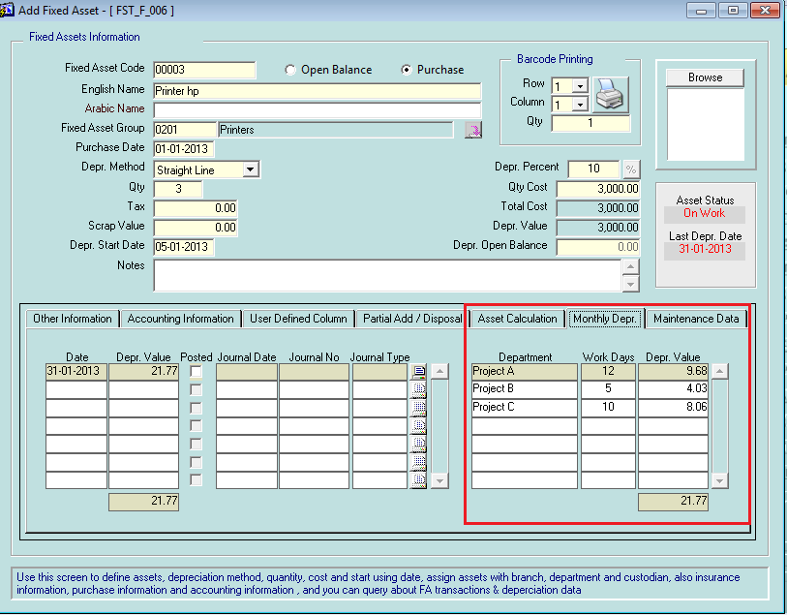

Now when u post the depreciation to GL it will posted with depreciation for each cost center for each asset or group of assets as shown

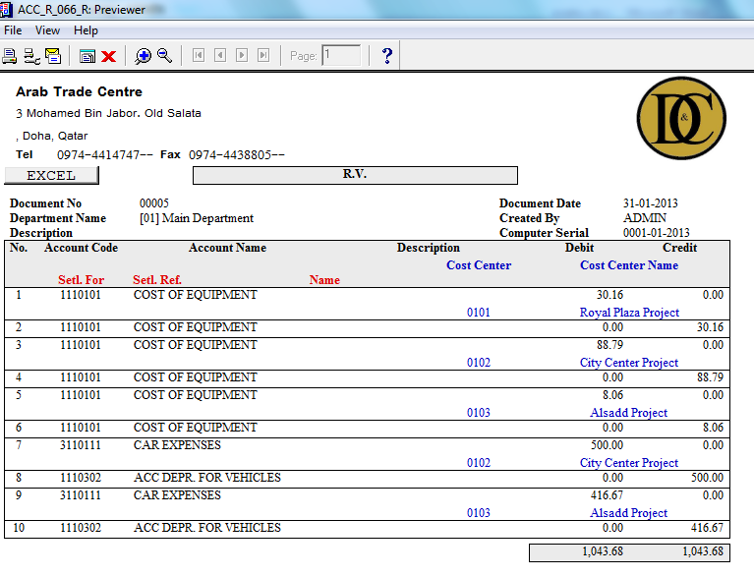

Notice that every department linked with cost center as shown

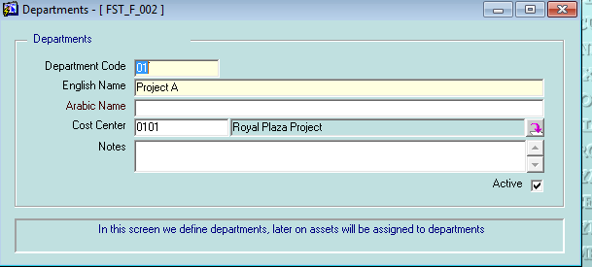

New screen added which show depreciation for each department

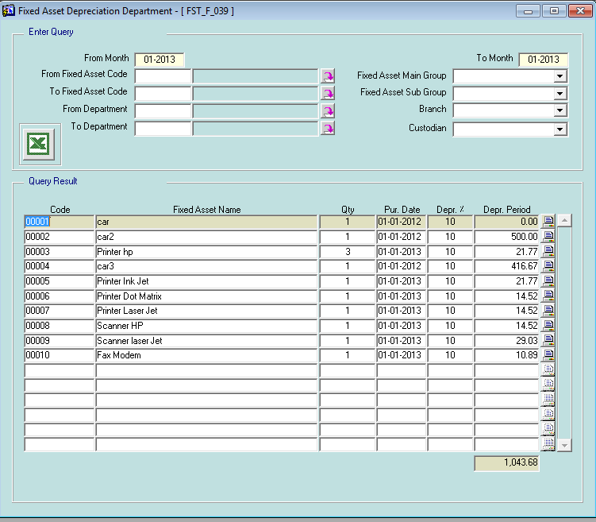

New report added to print the depreciation for every department

